Project Design Phase-I
Solution Architecture – Electric Vehicle Market Performance & Insights

Date | 26 October 2026
Team ID
Project Name | Electric Vehicle Market Performance & Insights
Maximum Marks | 4 Marks

Solution Architecture:
Solution architecture for this project describes how the supplied electric-vehicle dataset is connected, reviewed, analysed and presented to users through Tableau Public and a public project website. The design is intentionally based on the tools actually used: a CSV dataset, Tableau Public and GitHub Pages.
- Identify a practical analytics solution for exploring EV market-performance and technology patterns in the supplied dataset.
- Describe the data flow, Tableau analysis layer, published dashboard, two stories and website for project stakeholders.
- Define the components, responsibilities, data limitations and delivery outputs without claiming unused Snowflake or SQL infrastructure.
- Provide a clear structure for building, validating, publishing and maintaining the EV analytics solution.

Project-Specific Solution Architecture Diagram:
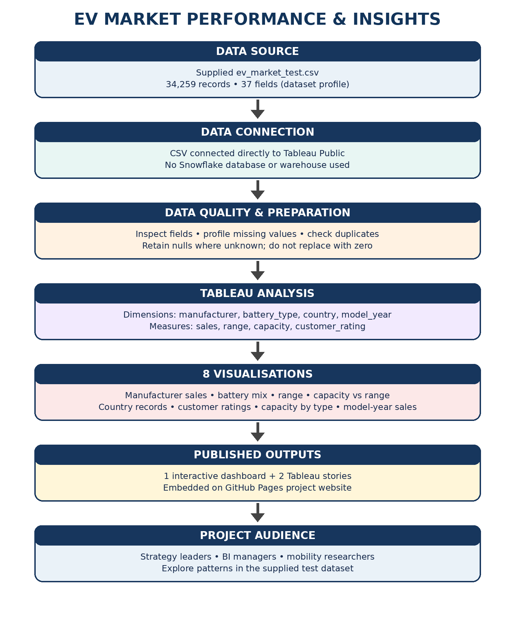

Component Description Table
Component | Technology / Tool | Description / Responsibility
Data source | ev_market_test.csv | Supplied test dataset used for all analysis; 34,259 rows and 37 columns as previously profiled.
Data connection | Tableau Public – CSV connection | Connects the CSV directly to Tableau for exploration and visualisation.
Data quality review | Tableau data source / profiling | Review missing values and duplicates; preserve unknown values rather than treating them as zero.
Analysis layer | Tableau dimensions and measures | Uses manufacturer, battery_type, manufacturing_country and model_year with sales, range, capacity and rating measures.
Visualisation layer | 8 Tableau charts | Covers manufacturer sales, battery technology distribution, driving range, capacity-range relationship, country records, customer ratings, battery capacity by type and model-year sales.
Dashboard | Tableau Public | Combines the visualisations into one interactive dashboard with available filters.
Storytelling | 2 Tableau Public stories | Story 1: EV Market Performance Overview. Story 2: EV Technology and Customer Insights.
Public website | GitHub Pages | Presents project overview, embedded dashboard, story links and methodology.
Users | Project stakeholders | Market strategy, business intelligence and sustainable mobility research audiences.
Component Name | Description / Role in Architecture | Technology Used

Published Project Links
GitHub repository: https://github.com/suryadevsingh0225/Electric-Vehicle-Market-Performance-Insights
GitHub Pages website: https://suryadevsingh0225.github.io/Electric-Vehicle-Market-Performance-Insights/
Tableau dashboard: https://public.tableau.com/app/profile/suryadev.singh/viz/EV_Market_Performance_Insights_17931646155280/ELECTRICVEHICLEMARKETPERFORMANCEINSIGHT?publish=yes
Tableau Story 1: https://public.tableau.com/app/profile/suryadev.singh/viz/EV_Market_Performance_InsightsStory1/EVMarketPerformanceOverview?publish=yes
Tableau Story 2: https://public.tableau.com/app/profile/suryadev.singh/viz/EV_Market_Performance_InsightsStory2/EVTechnologyandCustomerInsights?publish=yes
Implementation note: Team member: Self. Team ID intentionally blank. No Snowflake database, warehouse, SQL scripts, ETL pipeline or cloud data warehouse is claimed. Dataset counts describe the supplied test file and should not be represented as verified global EV market statistics.

